Color Wheel Art Activity

Supplies:

Color Wheel Chart
Markers
Coffee filters
Tin foil squares
Card stock
Scissors
Glue

Class discussion:
Q: What is the Color Wheel?

A: The color wheel is a circle with different colors showing the relationship between the colors.

Q: How do we use the color wheel in art?

A: The color wheel is the easiest way to find out how colors mix together to create new colors.

Let’s do an activity to learn what the primary colors, secondary colors and tertiary colors are!

Activity

Time to make your own color wheels!

- Have each student take a coffee filter, tin foil square and set of markers (red, yellow, blue).
- Students should fold the coffee filter into thirds and place it on the tin foil to protect the table.
- Have the student color the center of each section of the coffee filter, leaving white space in between each color section. The point is to NOT color it all the way in leaving room between the sections for the colors to bleed together and create new colors. THESE THREE COLORS ARE PRIMARY COLORS (red, blue, and yellow)
- Once the coffee filters are colored, have the students spray them with water and watch the colors bleed together. THE COLORS CREATED BY MIXING PRIMARY COLORS ARE CALLED SECONDARY COLORS (orange, green, violet/purple)
- Using a second coffee filter have the students fold the filter in half and then in to thirds to create six sections. Now color the center of these sections using red, orange, yellow, green, blue and purple markers, in rainbow order, once again with spaces in between so there is room for the new colors.
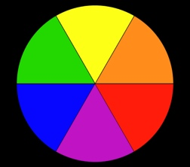

THE NEW COLORS CREATED AFTER THE SECONDARY COLORS BLEED TOGETHER ARE CALLED TERITIARY COLORS
- After this, students can use other filters to create new color combinations (it makes really fun tie-dye creations). 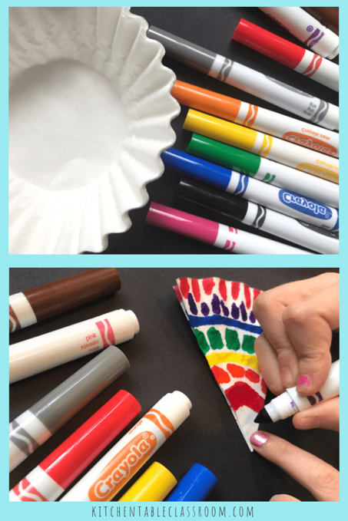
- Once they have several filters done, they can cut out shapes in the construction paper and glue the filters to them to create fun wreathes and wall décor. (this can be a great way to do Thanksgiving/Xmas wreathes for parent gifts)
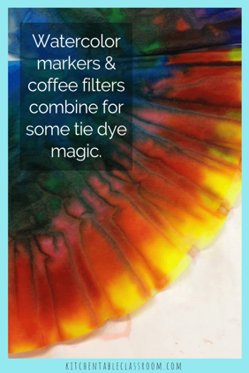
Clean up and return the cart

PRIMARY COLORS CREATE SECONDARY COLORS

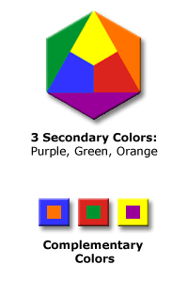

SECONDARY COLORS CREATE TERTIARY COLORS

